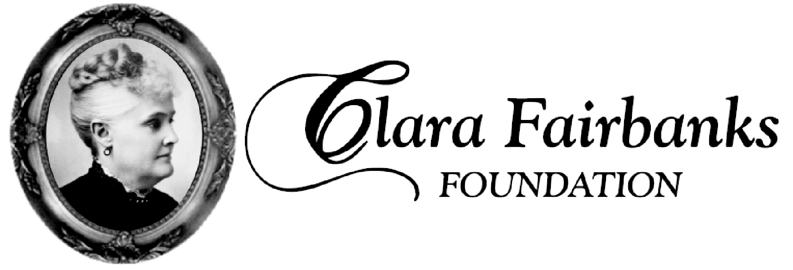
For the betterment of people in Vigo County

CLARA FAIRBANKS FOUNDATION, INC.’S Mission is to enrich and enhance the quality of life in Vigo County, Indiana. Primary consideration for funding is for projects that benefit disadvantaged women, children, and families. Funding projects to sustain existing philanthropic organizations through grants in the areas of human health and welfare, community development, education, the arts, and religion.

- CFFI does not favor start-up projects with a plan for long-term funding.

- The CFFI’s commitment to a project is limited to a fixed period usually a year. A Plan for future funding must be requested, unless the project is to be terminated by design.

- CFFI does not favor funding 100% of the cost of a project. Other foundations, agencies or sponsors should pledge matching funds.

- CFFI appreciates some type of visible recognition for its contributions, where applicable. To honor the memory of Clara Fairbanks.

- An elaborate proposal is unnecessary! Please fill out the summary sheet, include a recent financial statement for the agency as a whole and a copy of the applicant’s determination letter (IRS non-profit status) is required. If a financial statement is not furnished; request for funding may not be approved. If the request is $2,000 or less, no financial statement is necessary.

- Please present all Project Summary Sheets by August 1st.

7. CFFI will notify gift recipients in writing of the amount of the donation and date of distribution.

Project No. __________

Date: _____/_____/______

CFFI SUMMARY SHEET

NAME OF PROJECT: ________________________________________*

NAME OF SPONSORING AGENCY: ________________________________*

CONTACT PERSON: ________________________________________*

ADDRESS: ________________________________________*

CITY: ___________________* STATE: ____* ZIP: _________-_______*

PHONE: (_____) - _______________ * FAX: (_____) - _______________*

E-MAIL: _______________________* T.I.N.: ______________________*

* All items required.

BRIEF DESCRIPTION OF PROJECT:

What pressing need will this project meet?

Is this a new project? ____

If not a new project, how was it previously funded?

Have you solicited this grant request to other charitable foundations?

If so, who are they?

How many women, children or families will be served by this project each year? _________

What will their ages be? __________

Will any criteria be applied to determine eligibility for participation in this project? _____

If so, please identify:

Time period to be covered by this project: ____________

Total project budget: ______________

Amount requested from CLARA FAIRBANKS FOUNDATION, INC. $__________

How will the balance of your budget be raised?

If this project is to run for more than one year, how will it be funded in the future?

What procedure will be followed in judging the success of this project?

Thank you for your time in filling out these important questions. We look forward to serving you in the near future.

